**Variables**

In programming languages, variables work like containers to hold numbers, phrases, or other important information used in several places of your code. For example - in the previous section we learned about arithmetic operators and we directly printed the output of arithmetic expression without storing it anywhere. But what if we want to store the sum of two variables and multiply it with a third variable and then print the output, in that case, we require a variable to hold the value.

Let's understand variables by a Python example. You need to create a new file or you can edit your previous file. The syntax to create a python file or open a Python file is sudo nano filename.py and I am using variables.py as my filename. Now type the code shown below in your Python file.

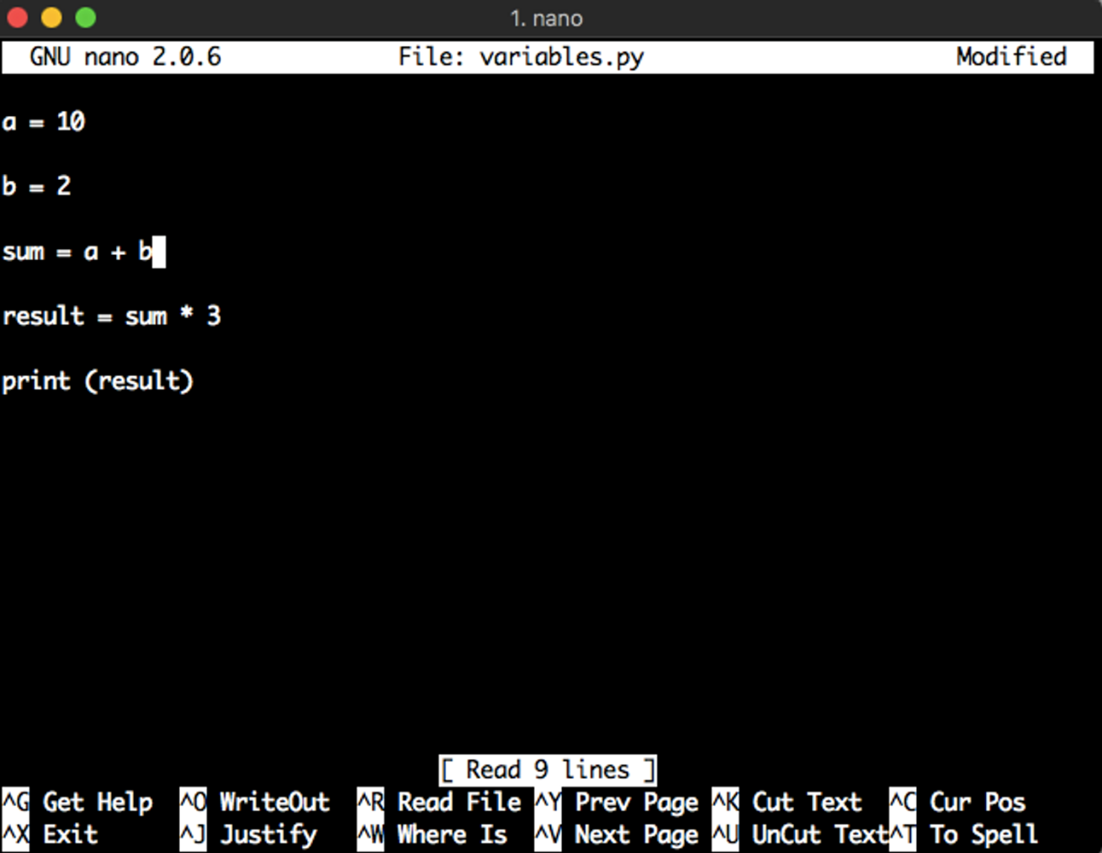

In the first line of the above code, **a** is a variable and we are storing the value 10 inside **a** ; In the second line we are storing 2 inside **b** and in the fourth line we are we are multiplying 3 to the sum and storing the result in a variable and in the last line, we are printing the result. Now we will run our file.

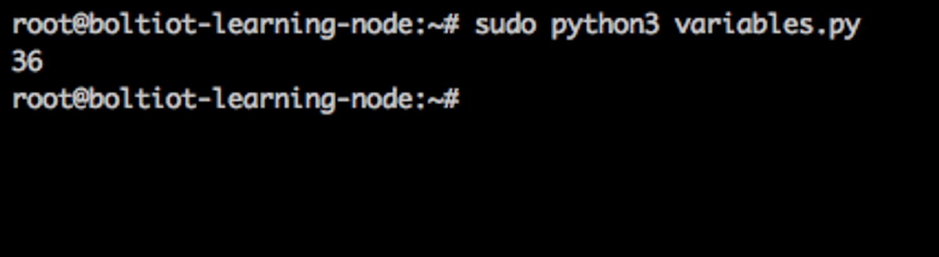

Notice that we have not mentioned the type of variable while declaring it. The Python language understands the type such as integer, float, and character based on the content of the variable. Also, note that upper case and lower case letters are considered as different variables. So 'A' is different from 'a' while assigning variable values.

In this section, we covered the basics of variables. In the next section, we will learn about conditional statements in Python.